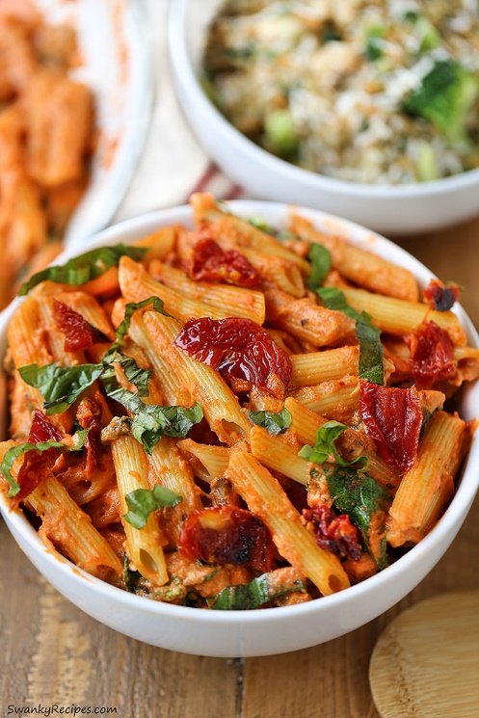

Mozzarella Penne Rosa Pasta with Sun Dried Tomatoes
Prep Time 5 min Cook Time 20 min
4 Servings

Ingredients
2 Tbsp olive oil
3 oz sun-dried tomatoes in oil
½ cup mushrooms, chopped
2 cloves garlic, minced or zested
¼ cup vegetable or chicken stock
8 oz penne pasta
½ Tbsp olive oil
1 jar (24 oz) marinara sauce
1/8 Tbsp red pepper flakes
¾ cup heavy cream or half & half
1 cup mozzarella, shredded
2 cups fresh baby spinach
¼ cup fresh basil, shredded (or ½ tablespoon dried basil)
¼ cup fresh Parmesan cheese, shredded

Directions
- Cook pasta according to package directions.
- Place oil in small skillet over medium low heat. Add chopped sundried tomatoes and cook for 2 minutes.
- Place oil in a large skillet over medium low heat. Add chopped mushrooms and sauté for 3 minutes, stirring with spatula.
- Stir in minced garlic and continue to sauté for 2-3 minutes making sure they don't burn.
- Add in broth and reduced heat to low.
- Stir in marinara sauce, red pepper flakes and sundried tomatoes. Then simmer for 10 minutes stirring it occasionally.
- Add in heavy cream and stir to combine for 3 minutes.
- Stir in shredded mozzarella cheese and combine.
- Fold in fresh baby spinach, combining everything well. Allow to cook for 5 minutes.
- Stir in penne pasta and dried basil. Top with chopped fresh basil, sun dried tomatoes and shredded parmesan cheese.

